Fast Transient Sensors - Coursework 3
Question 1
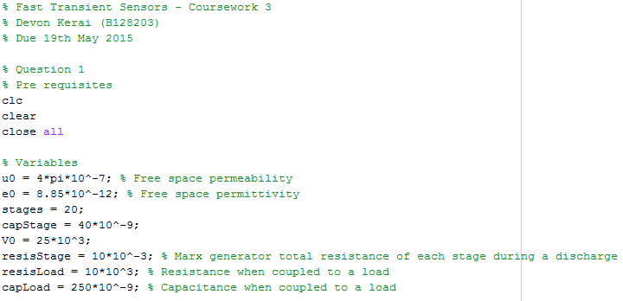
i)
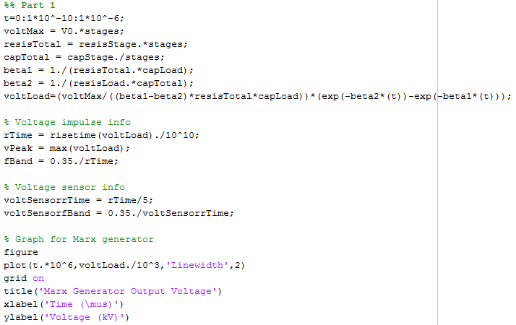
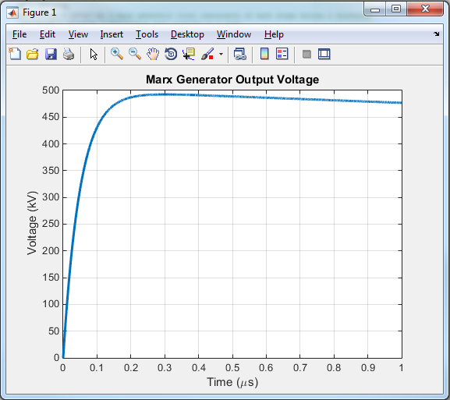
Answers: Peak Voltage = 492.550kV, Rise Time = 98.37ns, Bandwidth = 3.56MHz, Voltage Sensor Rise Time = 19.68ns, Voltage Sensor bandwidth = 17.77MHz.
ii)
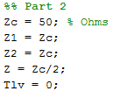
iii)
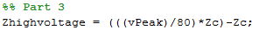
Answer: 30.78kΩ
iv)
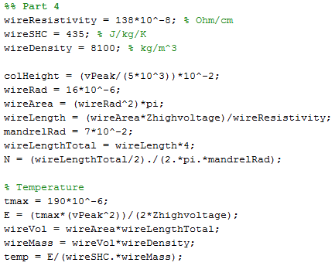
Answer: Column Height = 0.98m, Wire length = 717.51m, Turns = 815, Temperature difference = 36.82K
v)
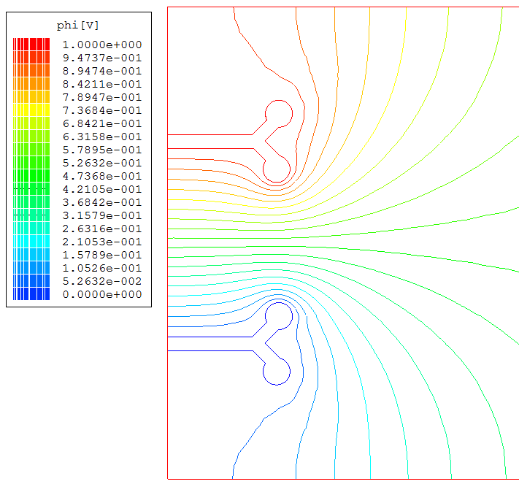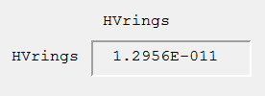
Answer: Capacitance = 13pF
vi)
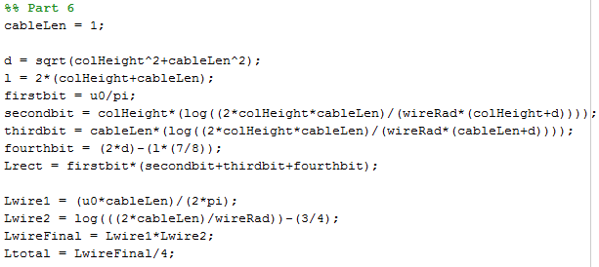
Answer: Inductance of a single wire = 0.55µH, Inductance of wires in parallel = 8.35µH. Approximating the high voltage arm to be a rectangle comprised of 4 wires and ignoring mutual inductance, the inductance of one individual wire is less than the inductance of the high voltage arm as a whole.
vii)
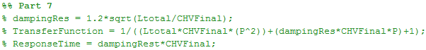
viii)
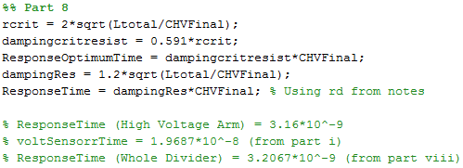
Answer: Response Time (Optimum Case) = 3.16ns, Response Time (Whole Divider) = 3.2ns. The response time is faster than the response time required from the voltage impulse from part i).
ix)
See Appendix 1.
x)
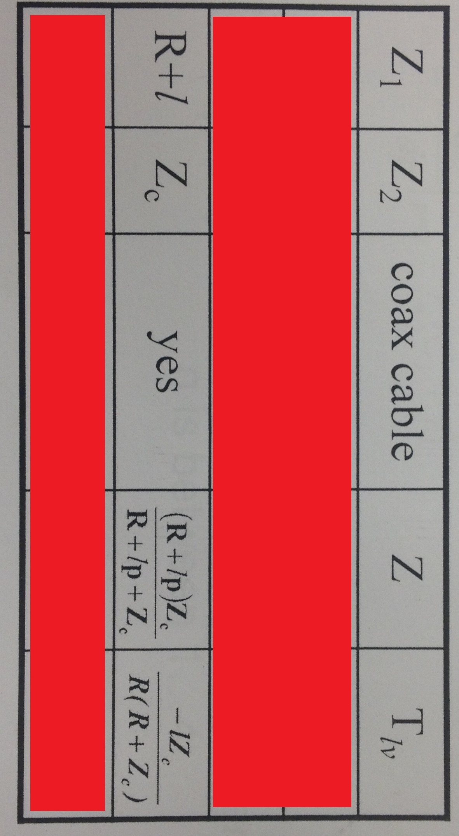
Answer: Using the above combination would improve the response time of the divider because it was cause the rise time for the low voltage arm to be negative, reducing the response time of the entire system.
Question 2
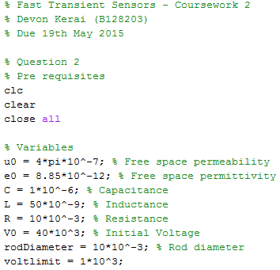
i)
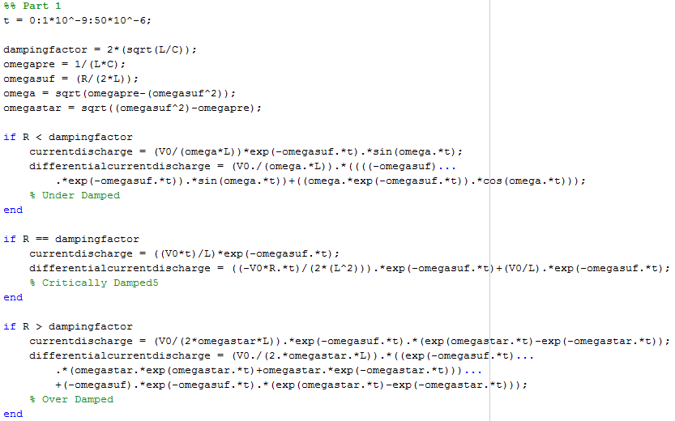
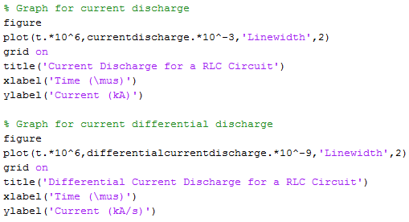
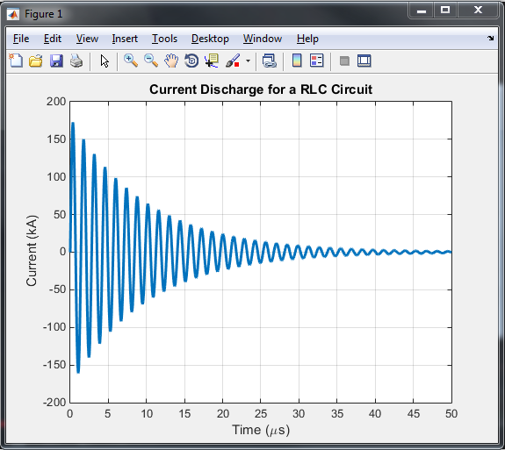
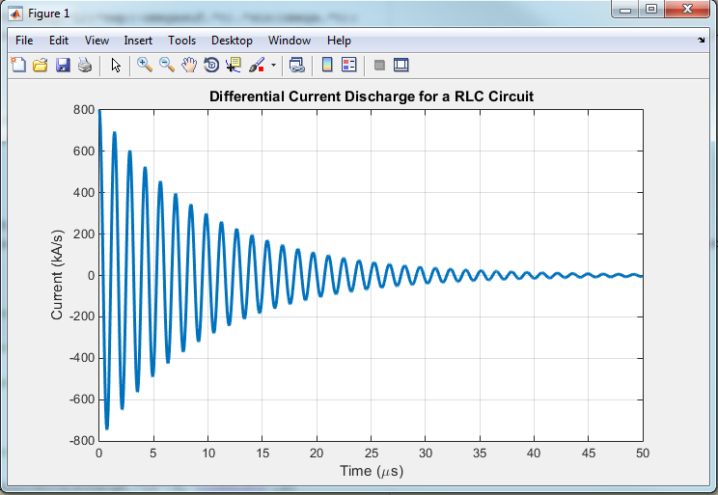
ii)
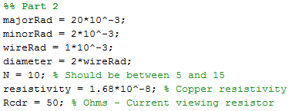
iii)
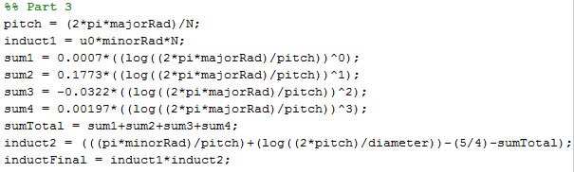
Answer: Self inductance = 38.2nH
iv)
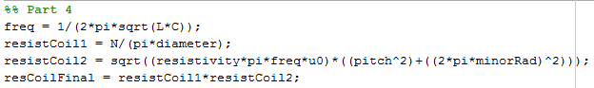
Answer: Resistance = 6.1mΩ
v)
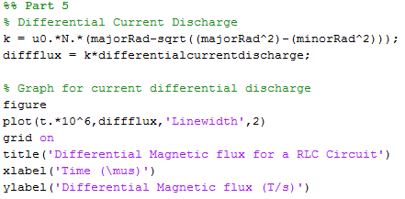
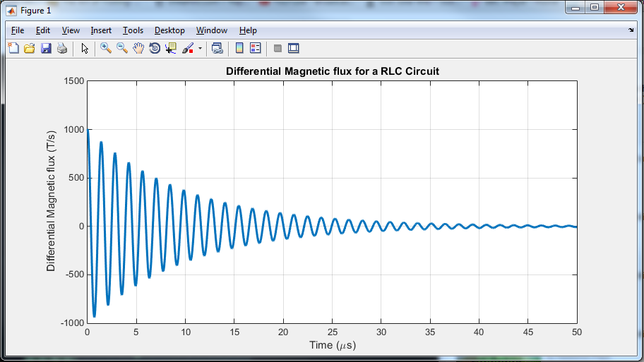
vi)
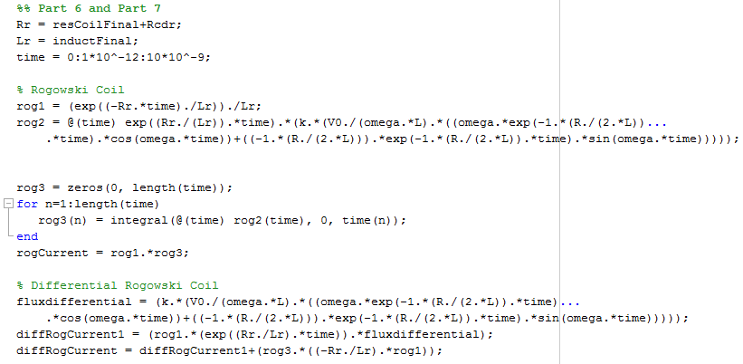
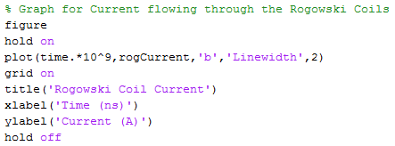
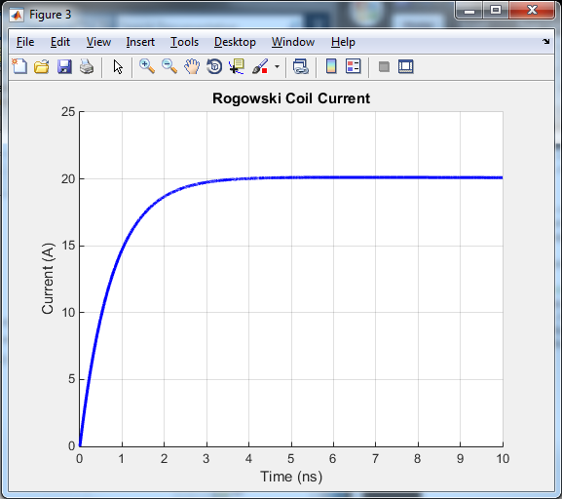
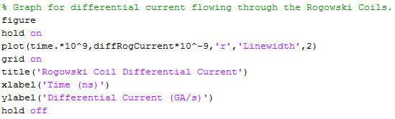
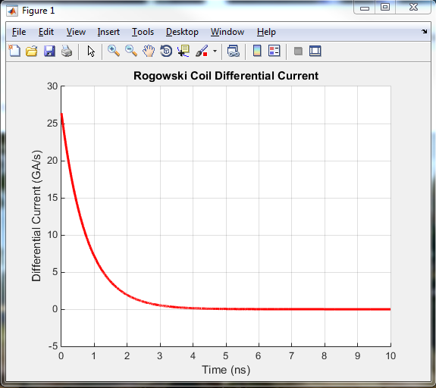
vii)
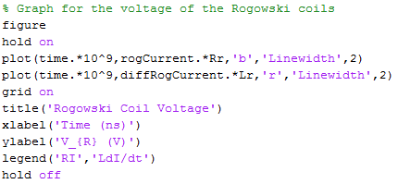
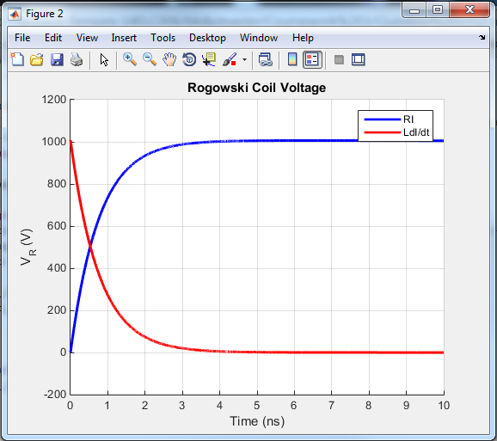
viii)
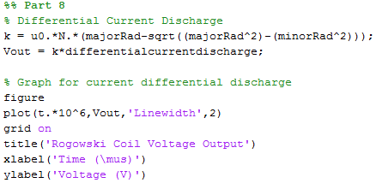
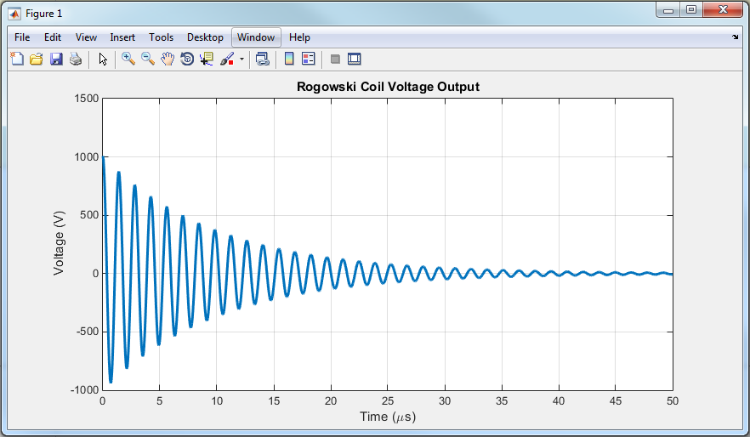
ix)
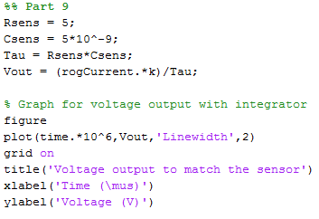
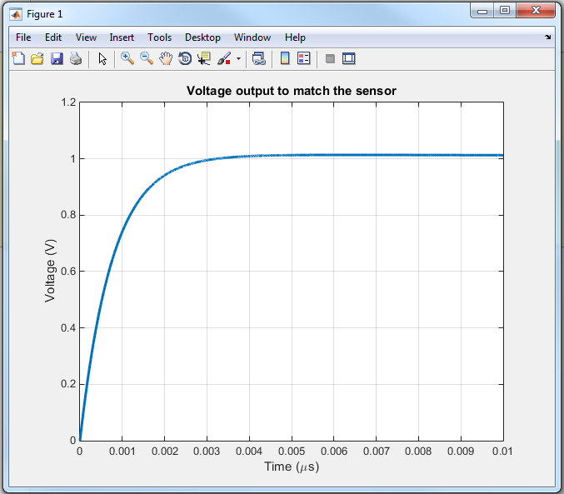
Question 3
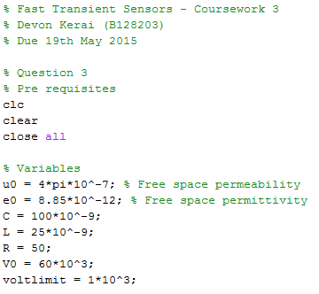
i)
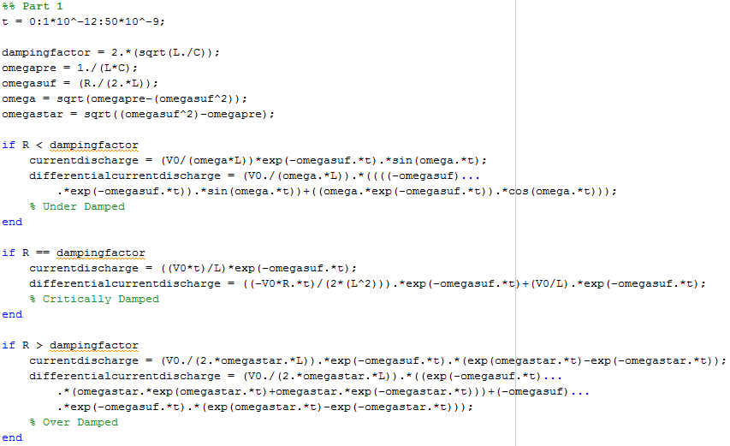
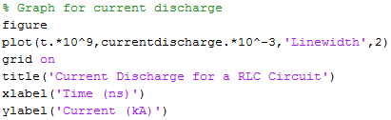
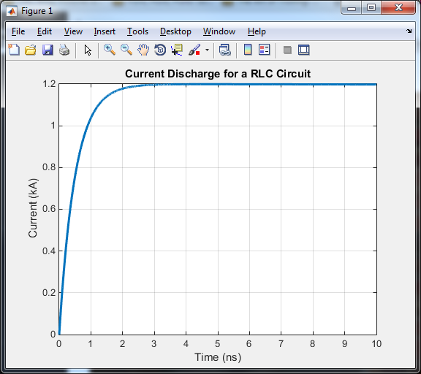
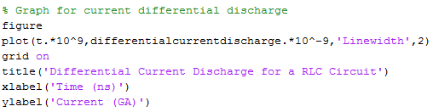
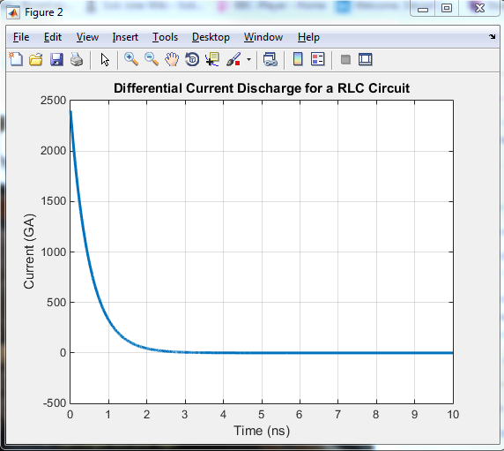
ii)
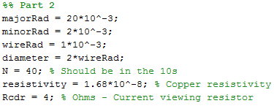
iii)
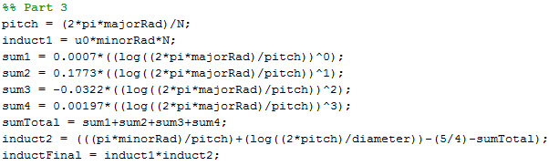
Answer: Self inductance = 0.16µH
iv)
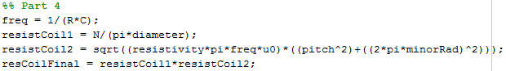
Answer: Resistance = 9.5mΩ
v)
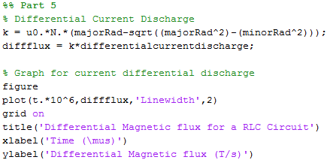
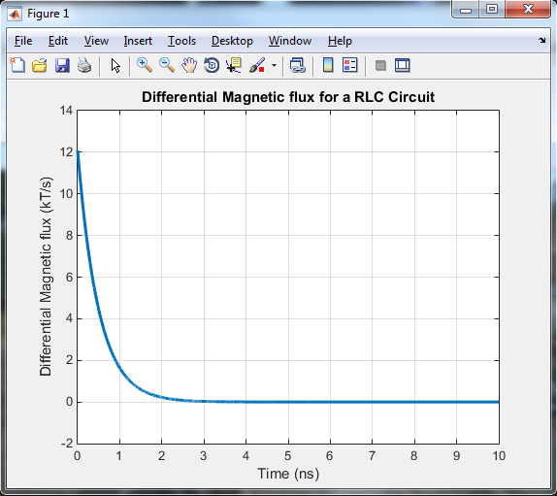
vi)
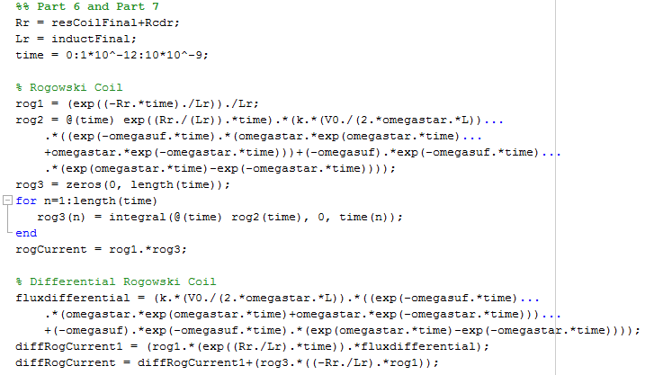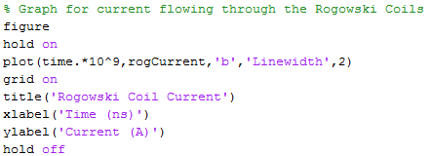
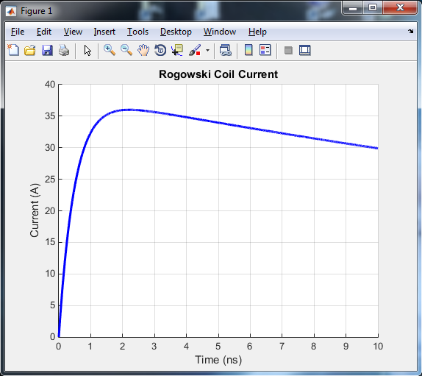
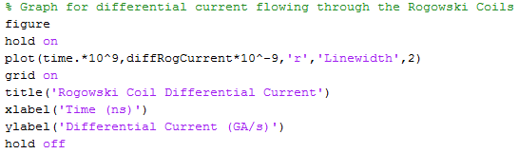
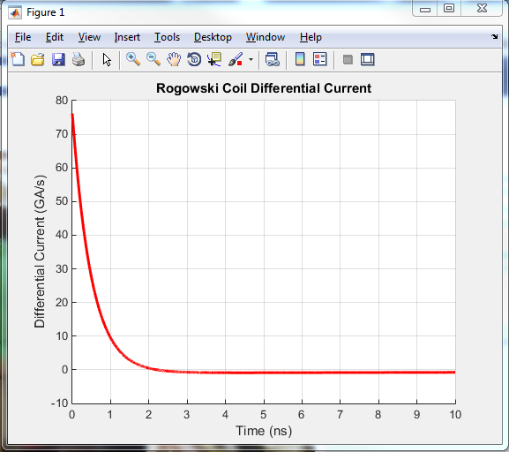
vii)
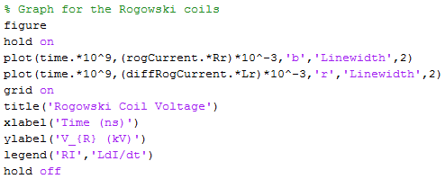
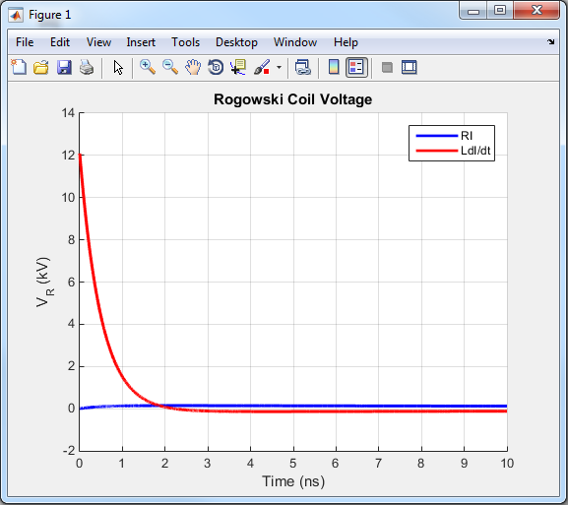
viii)
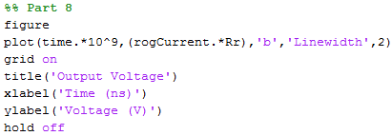
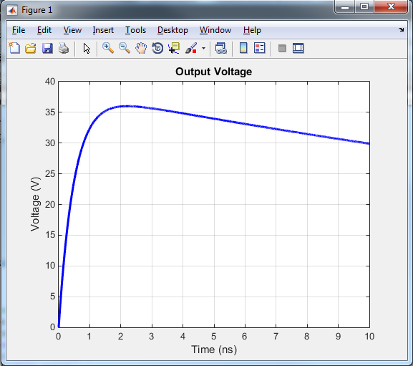
Question 4
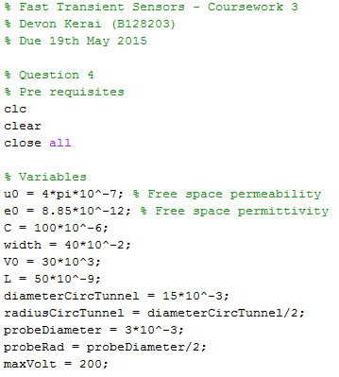
i)
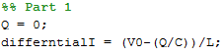
Answer: Peak current rate of change = 0.6TA
ii)
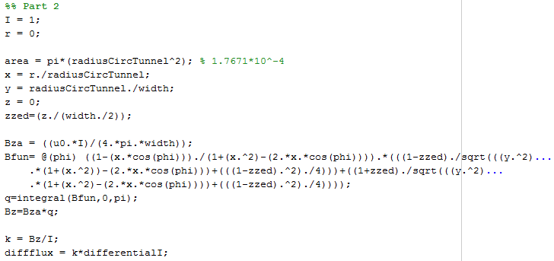Answer: 1.88MT
iii)
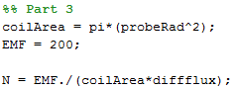
Answer: Turns = 15
iv)
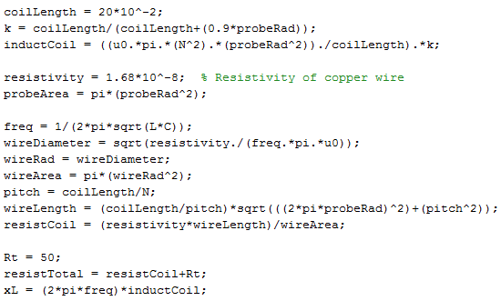
Answer: xL = 0.0045, total resistance = 50.02. Since xL << total resistance, the probe is differentiating.
v)
Answer: The calibration procedure is used to either obtain L and R or to calibrate a current or voltage sensor. During a high current discharge, both the inductance and resistance change. The movement of the conductors causes the inductance to change and the dL/dt increases the total resistance of the circuit. Due to the closing switch, the circuit resistance is not constant.
vi)
See Appendix 2.
vii)
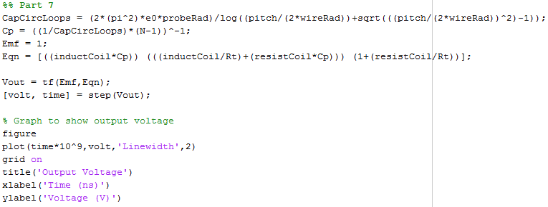
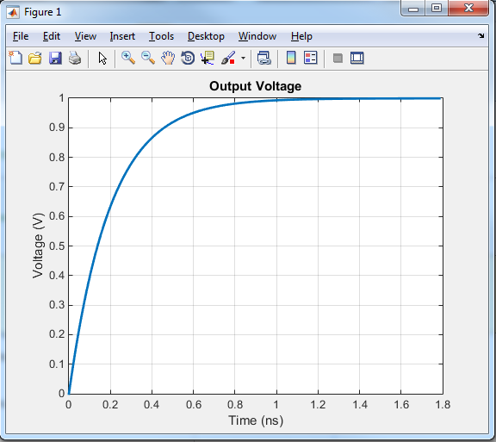
Bonus Question:
See Appendix 3.

